SIGN LANGUAGE DETECTION
BASED ON OPENCV AND PYTHON

INTRODUCTION

Inability to speak is considered to be true disability. People with this disability use different modes to communicate with others, there are number of methods available for their communication one such common method of
communication is sign language.

PROBLEM:
Developing sign language application for deaf people can be very important, as they’ll be able to communicate easily with even those who don’t understand sign language. The project aims at taking the basic step in bridging the
communication gap between normal people, deaf and dumb people using sign language.

The main focus of this work is to create a vision based system to identify sign
language gestures from the camera in real time. The reason for choosing a system based on vision relates to the fact that it provides a simpler and more intuitive way of communication between a human and a computer. In this report, a different approach is considered and implemented as opposed to the standard norm, using Contour Analysis and Feature Extraction techniques.

SOLUTION:
The goal of this project is to design a program for extraction of human hand properties based on OpenCV. Implement proposed solution into desktop application with properly designed graphical interface and evaluate effectiveness of design.

ANALYTICAL CONSIDERATIONS:

Even the most sophisticated machines are unusable when they are not controllable by human. The ideal interfaces must fullfill two requirements. They must be functional and usable. The design of such interfaces between humans and computers heavily depends on available technologies and target groups. Based on different criterions, it's possible to separate human-computer interfaces into several groups and these are visually based, audio based and sensor based.

The methodology discussed here is based on visual interfaces.

WORKING PRINCIPLE:

Human hand is seen by lens inside camera device and the image is converted into its digital representation. Digital image is nothing more than matrix of scalar or vector values (depends on whether the image is monochromatic or coloured) and it can be processed in numerous ways.
That is where OpenCV library may be used, since it is optimized for such operations.

Contour of object is defined by set of points, which describe the edge of object, the outline.
For example, the contour of tennis ball is circle.

Numerous algorithms for finding contour in digital image were proposed and one of the first was proposed by Theo Pavlidis , where his algorithm is considered as base stone of all others.

OpenCV library offers very efficient implementation of contour finding algorithm, which contains additional features like extraction of contours in hierarchy and approximation of found contours. Approximation of line contour with set of points is very handy feature and significantly speeds up further processing of contour. Such contour, represented as set of points, can be enclosed into n-dimensional polygon, also known as hull.

Hull, as the geometrical shape, can be concave or convex polygon. We can say that the hull is convex, when it is not possible to draw a line inside polygon which would intersect its border. If it is possible, then the polygon is not convex and therefore contains convexity defects.
These area descriptive properties will significantly help with design of algorithm since human hand does have huge convexity defects between fingers.

PRINCIPLE AT WORK:

image detection with contours can be understood with the help of the following definitions.
Contours can be explained simply as a curve joining all the continuous points (along the boundary), having same color or intensity. The contours are a useful tool for shape analysis and object detection and recognition.
For better accuracy, use binary images. So before finding contours, apply threshold or canny edge detection.’findContours’ function modifies the source image. So if you want source image even after finding contours, already store it to some other variables. In OpenCV, finding contours is like finding white object from black background. So remember, object to be found should be white and background should be black.
OpenCV and Python code for contours
import numpy as np
import cv2

im = cv2.imread('test.jpg')
imgray = cv2.cvtColor(im,cv2.COLOR_BGR2GRAY)
ret,thresh = cv2.threshold(imgray,127,255,0)
image, contours, hierarchy = cv2.findContours(thresh,cv2.RETR_TREE,cv2.CHAIN_APPROX_SIMPLE)

here are three arguments in cv2.findContours() function, first one is source image, second is contour retrieval mode, third is contour approximation method. And it outputs the image, contours and hierarchy. contours is a Python list of all the contours in the image. Each individual contour is a Numpy array of (x,y) coordinates of boundary points of the object. To draw the contours, cv2.drawContours function is used
To draw all the contours in an image:
img = cv2.drawContours(img, contours, -1, (0,255,0), 3)
the third argument in cv2.findContours function is the contour approximation method

- Creation of Threshold
Creation of thresholded image is very crucial for Hand detection .
Isolating the foreground from the Background is essential as we want the hand to be the region of Interest.
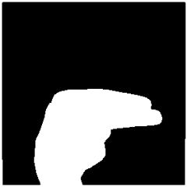
Figure 1. Thresholded Image of The Letter “H”

- Finding Contours
The Hand is identified using an inbuilt function that finds Contours which OpenCV provides .
The function is later then returns an array of co-ordinates of the formation of the Contour.
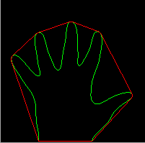

C. Convex Hull and Convexity Defects
The data from the Contour Analysis is later manipulated to obtain an entity known as “Number of Convexity Defects”. Convexity Defects are irregularities in the contour . Based on the value of this , we can Identify how many fingers are present . This is valuable information as it provides information as to which Letter is corresponding.
The number of contour defects is calculated by the following process .
We compute a triangle . Let the sides be “a” ,”b” and “c” . This triangle is formed by the starting point of the contour , the ending point of the contour and the farthest point of the contour . (a , b , c respectively ) . “a” is computed as follows
a = math.sqrt((end[0] - start[0])**2 + (end[1] - start[1])**2) [7]
Similarly , b and c are also calculated .

Now, using the Cosine rule ,
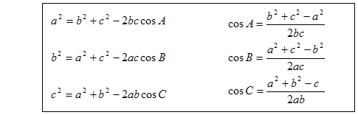
The angle A is calculated .
If the angle A is less than or equal to 90 degrees , it means that there is a convexity defect . Once there is a convexity defect recognised , a variable by the name “cnt” increments by one .
So , by this algorithm we can efficiently identify how many convexity defects there are

OpenCV and Convex hull

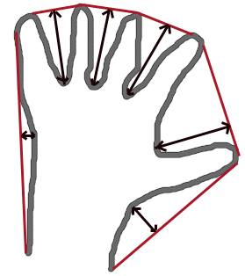
Convex Hull will look similar to contour approximation, but it is not (Both may provide same results in some cases). Here, cv2.convexHull() function checks a curve for convexity defects and corrects it. Generally speaking, convex curves are the curves which are always bulged out, or at-least flat. And if it is bulged inside, it is called convexity defects. For example, check the below image of hand. Red line shows the convex hull of hand. The double-sided arrow marks shows the convexity defects, which are the local maximum deviations of hull from contours.

There is a little bit things to discuss about it its syntax:
hull = cv2.convexHull(points[, hull[, clockwise[, returnPoints]]
Arguments details:
- points are the contours we pass into.
- hull is the output, normally we avoid it.
- clockwise : Orientation flag. If it is True, the output convex hull is oriented clockwise. Otherwise, it is oriented counter-clockwise.
- returnPoints : By default, True. Then it returns the coordinates of the hull points. If False, it returns the indices of contour points corresponding to the hull points.

CHECKING CONVEXITY:
There is a function to check if a curve is convex or not, cv2.isContourConvex(). It just returns whether True or False.
k = cv2.isContourConvex(cnt)

IDENTIFICATION OF LETTERS
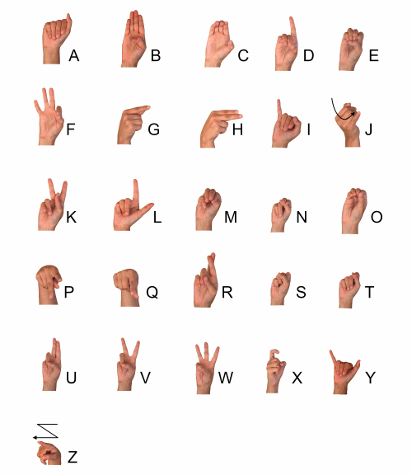
.

Letter A: For identifying A , I computed the difference between the area of a circle and the area of the contour . The circle is obtained by bounding the contour . The reason this method is adopted for A is that there is very little difference between the two areas (mentioned above ) which makes the Letter A stand out from the other letters . Hence this algorithm was found to be very efficient .
Letter B: For the letter B , I computed the contour area . This method is adopted because the Letter B has the largest area among the other letters .
Letters V, C, L, Y: This part gets executed when the Letter A fails . If the number of convexity defects are equal to 1 , the following algorithm is employed .
The “angle” is calculated . This entity is obtained by an OpenCV inbuilt function that calculates the overall figure’s orientation , giving us an angle . Based on the values of the angle , Letters V , C, L and Y are identified .

Letters F and W: Letters F and W are the only alphabets in the American Sign Language to have 2 convexity defects . Once 2 convexity defects are identified , the angle is compared . Hence the Letters F and W are identified in this manner.
Letters D, J, H, I, U: A combination of parameters are computed to identify these letters ,
Solidity , Aspect ratio and Angles are computed .
On intensive testing of Contour Parameters , I found the above parameters to be reliable and efficient .

Analysing Contour Properties

Various Contour properties are computed to identify the letter made . They are listed as follows :
- Aspect Ratio : It is the ratio of width to height of bounding rect of the object.
x,y,w,h = cv2.boundingRect(cnt)
aspect_ratio = float(w)/h
- Perimeter of Contour :
It is also called arc length. It can be found out using cv2.arcLength() function. Second argument specify whether shape is a closed contour (if passed True), or just a curve.
perimeter = cv2.arcLength(cnt,True)
- Area of Contour :
Contour area is given by the function cv2.contourArea() or from moments, M[‘m00’].
area = cv2.contourArea(cnt)
- Equivalent Diameter of Contour Area
- Solidity is the ratio of contour area to its convex hull area
area = cv2.contourArea(cnt)
hull = cv2.convexHull(cnt)
hull_area = cv2.contourArea(hull)
solidity = float(area)/hull_area
- Number of Convexity Defects
- Angle
- Bounding Rectangle Area
- Moments :
The function cv2.moments() gives a dictionary of all moment values calculated. See below:
import cv2
import numpy as np

img = cv2.imread('star.jpg',0)
ret,thresh = cv2.threshold(img,127,255,0)
contours,hierarchy = cv2.findContours(thresh, 1, 2)

cnt = contours[0]
M = cv2.moments(cnt)
print M
From this moments, you can extract useful data like area, centroid etc.
cx = int(M['m10']/M['m00'])
cy = int(M['m01']/M['m00'])

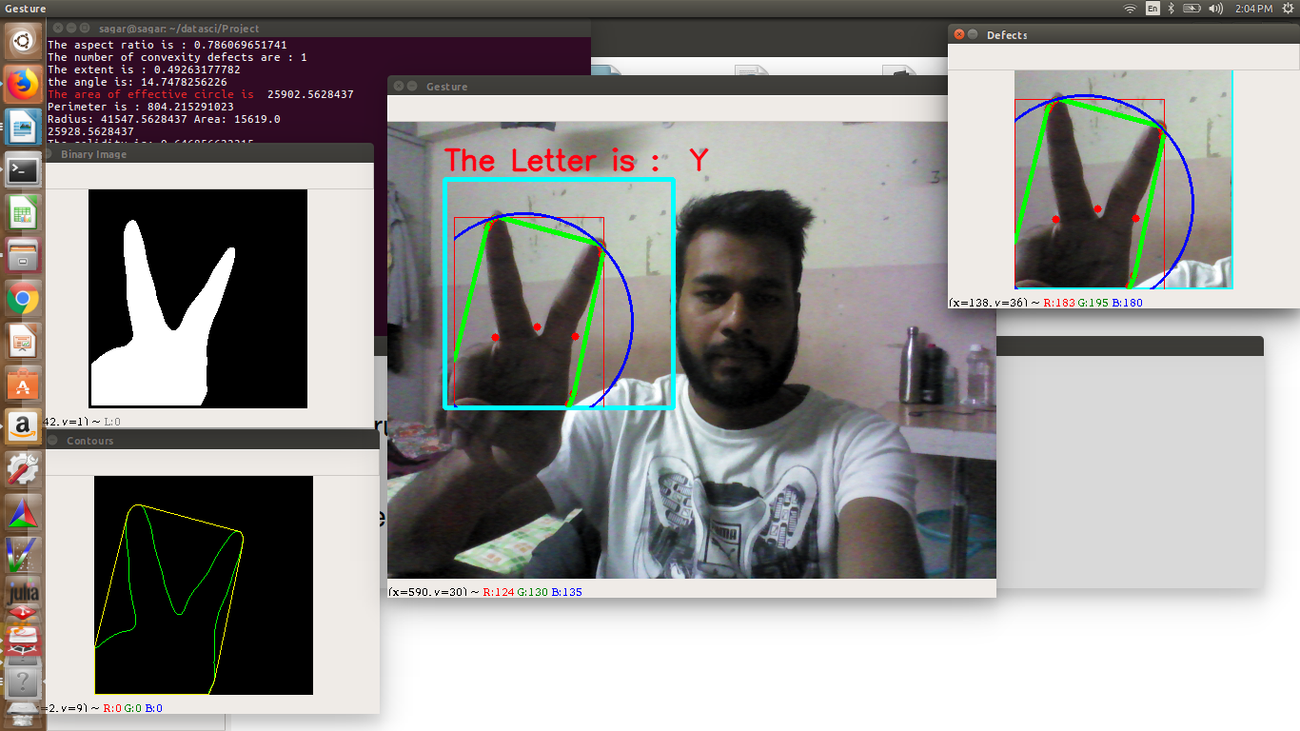

Analysis Of Hand with various methods .

Output Of The Identified Letter
After the identification of a Letter , the challenge IS to play an audio file which played “ The Letter is (Letter recognised)” . But once I played the audio file , it wasn’t getting completed . This is because the frame of the video stream keeps changing rapidly , not giving enough time for the audio file to finish . To overcome this problem , a bash script can be written to handle the audio part . It’s working is given below .
Once a corresponding Letter is identified The algorithm is given as follows .
For example , The letter “U” is identified , I make a directory and navigate into that directory . Then a “.txt” file is made containing the “U”. If U already exists , it is overwritten .
Next , I wrote a Shell Script which goes into the directory and finds the last modified file , using its corresponding time stamp . Once the last modified file is found ,
The script plays the corresponding audio file . This approach doesn’t depend on the python program .

FUTURE SCOPE OF MACHINE LEARNING IN OBJECT RECOGNITION:

When performing standard image classification, given an input image, we present it to our neural network, and we obtain a single class label and perhaps a probability associated with the class label as well. This class label is meant to characterize the contents of the entire image, or at least the most dominant, visible contents of the image.
For example, given the input image a CNN classifier has labeled the image as some xyz.
We can thus think of image classification as:
- One image in
- And one class label out
Object detection, regardless of whether performed via deep learning or other computer vision techniques, builds on image classification and seeks to localize exactly where in the image each object appears. The project can be extended to training a set of values based on their contour features to efficiently recognize the Sign Language.
Furthermore, the concept of facial recognition can be implented as a result of this algorithm. Since most of the commercially available facial recognitions use the HOG method of detecting a triangulated point on the face, they can sometimes resut in a tricky situations. The contour method of detecting edges is an enhanced way of detecting a facial feature.

